Secloud service description

You are now reading the service description for secloud, including our two offerings secloud Elimino and secloud azetwyze.
Our solutions is designed to help organizations strengthen their data security practices, maintain regulatory compliance, optimize their assets, and reduce overall risk.

Overview of secloud

secloud is an integrated platform designed to help organizations discover, protect, erase, and manage data across their entire IT infrastructure. By combining asset visibility, risk assessment, compliance management, and secure data erasure, secloud enables businesses to confidently implement robust cybersecurity and privacy measures without adding complexity to their daily operations.

Key platform benefits

- Holistic visibility: Unified dashboards and reporting across assets, risks, and compliance status.
- Scalable architecture: Adapts to organizations of all sizes, from small businesses to large enterprises.
- Regulatory alignment: Built-in compliance features to major data protection standards (GDPR, NIST, ISO 27001, etc.).
- Secure erasure & sanitization: Advanced tools for secure data removal to mitigate data exposure risks.
- Modular & integratable: Each module (Azetwyze, Risk Radar, Compliance Pulse, Elimino, Eliminato) can function independently or as part of a larger secloud ecosystem and be integrated with your other solutions for a better day.

Secloud azetwyze

Purpose & functionality
Azetwyze provides comprehensive asset inventory and lifecycle management for all hardware and software assets within an organization’s environment. It automatically discovers, classifies, and tracks endpoints, servers, cloud resources, and other IT elements, ensuring that security teams have real-time visibility into where sensitive data may reside.

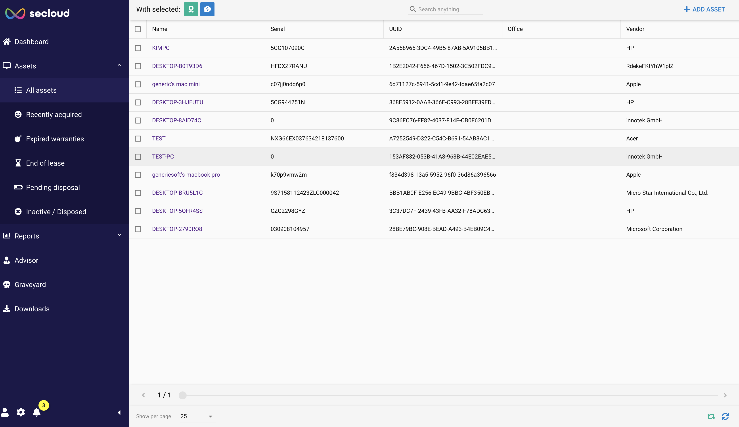

Key Features

Automated asset discovery:
- Leverages network scanning, agent-based detection, uploads and API integrations to locate devices and software.
- Keeps asset data up to date in real-time (hardware specs, OS versions, installed applications).

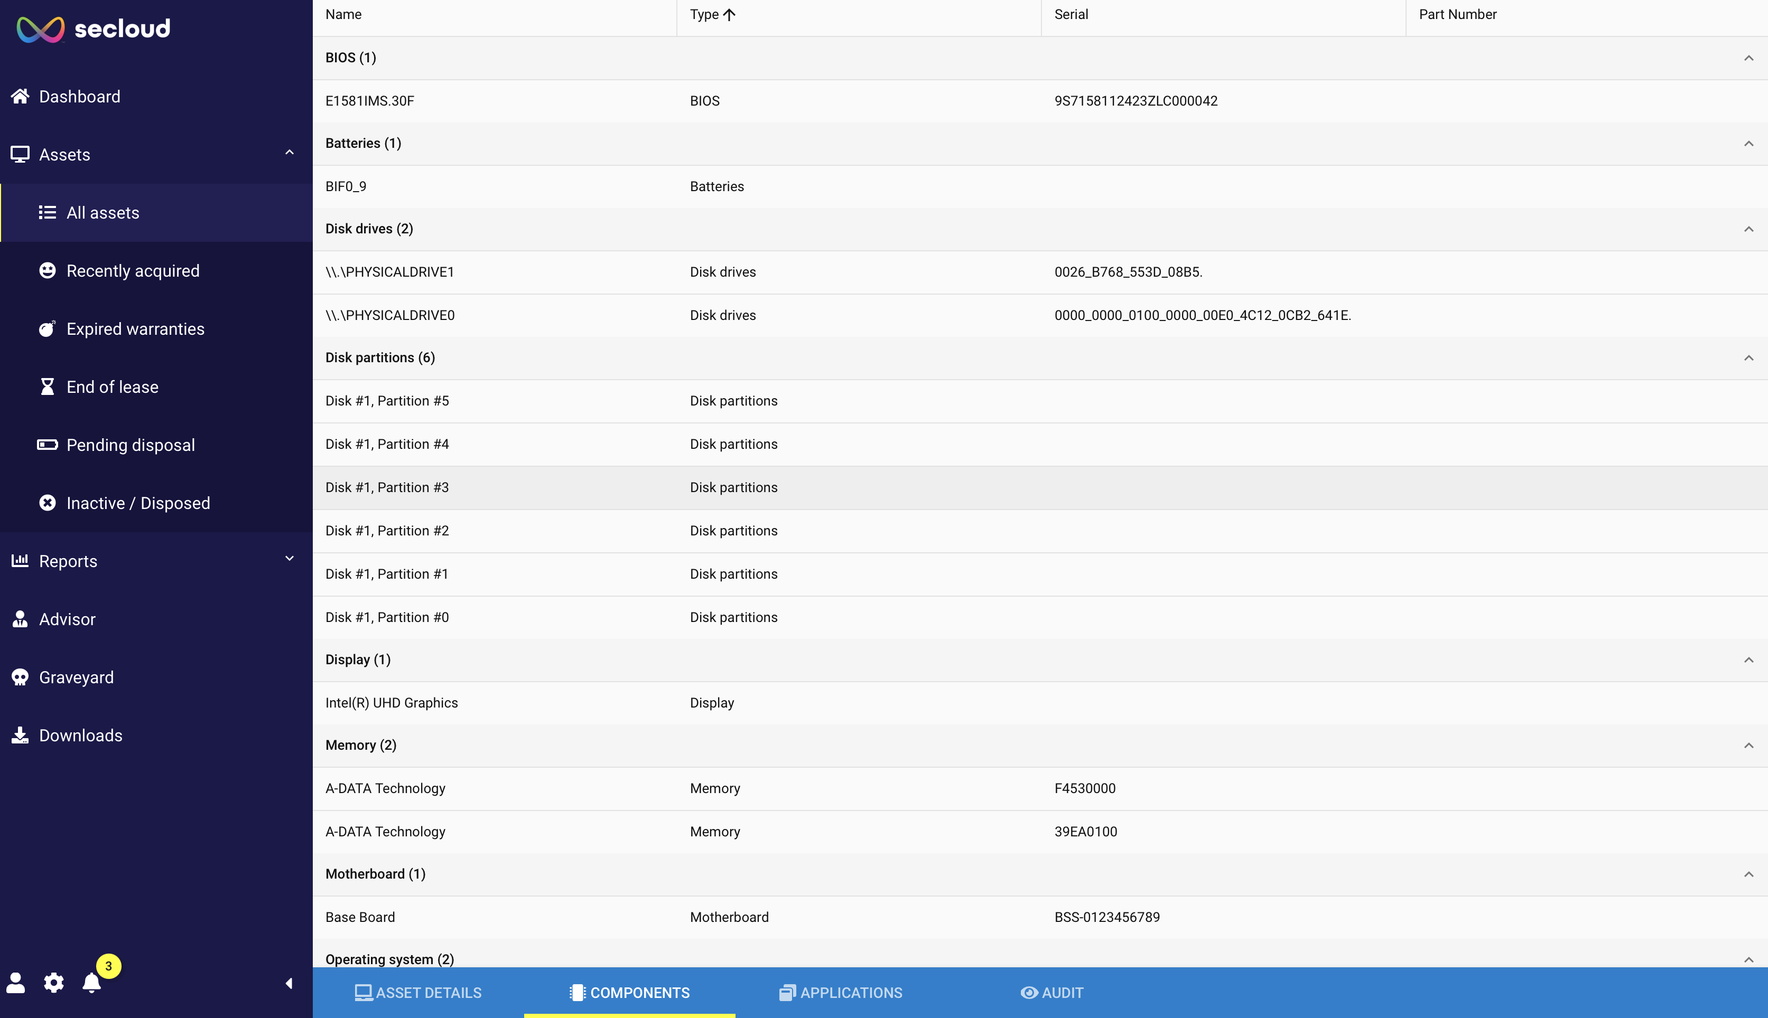

Categorization & tagging:

- Classifies assets by type (e.g., laptop, server, VM) and usage (e.g., production, staging).

- Allows custom labels to map assets to business units, locations, or project teams.

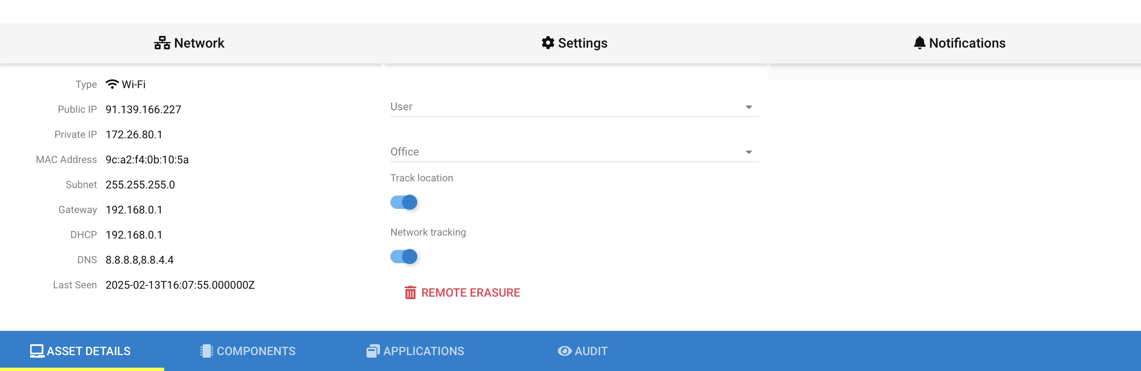

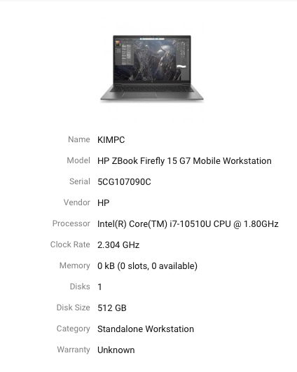

Lifecycle tracking:
- Monitors each asset’s status from procurement to decommissioning.
- Tracks warranty, end- of lease, disposed/pending disposal and inactive/disposed devices.
- Upon disposal or re-use or as part of the decision process you can create an audit for the device
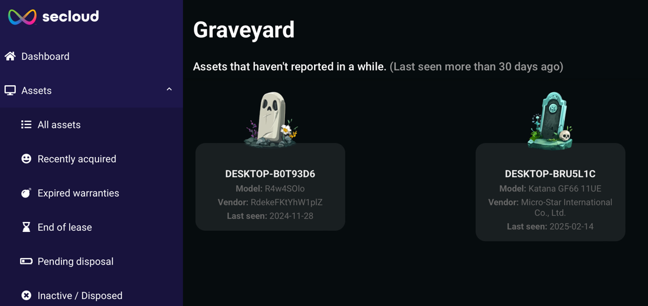
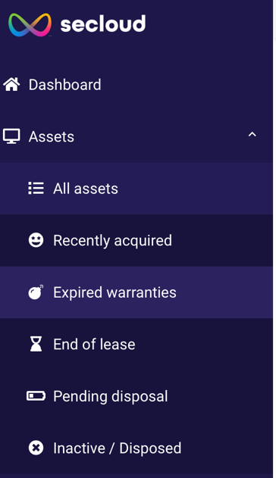

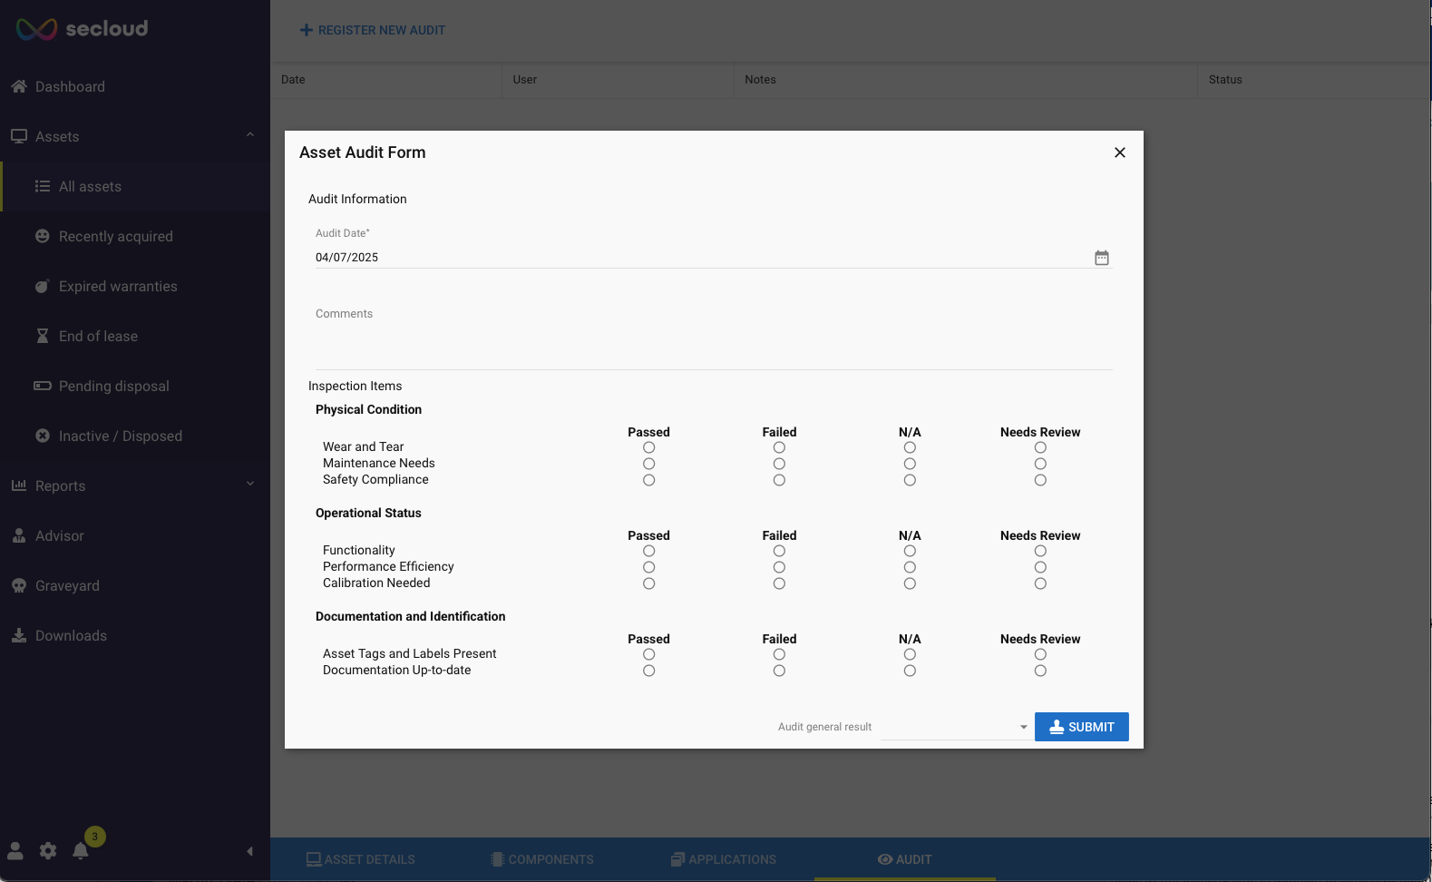

Advisory
With secloud azetwyze you´ll get your personal advisor that will tell you about security risks, upgrade possibilities, privacy concerns and other. Meaning you have an intuitive, up to date overview of the status of your devices and you can make educated decisions on what to prioritize.

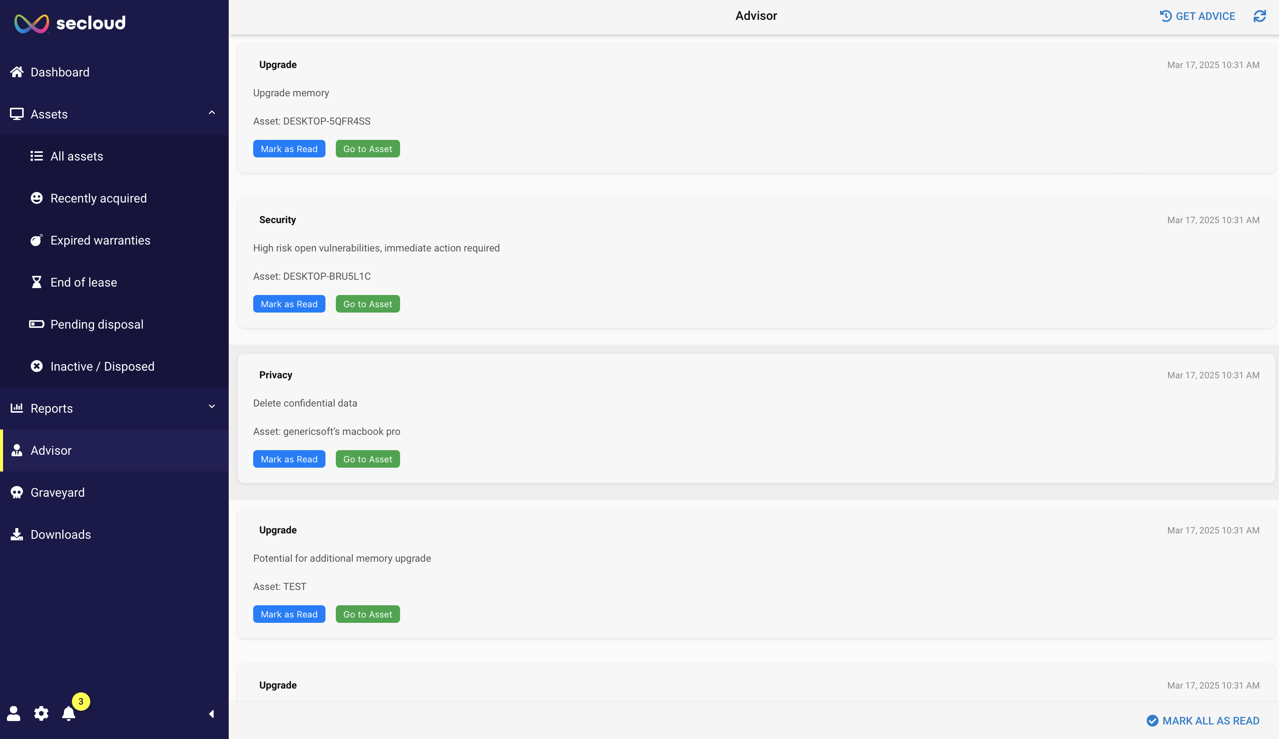

Integration & reporting:
- Supports integration with CMDBs (Configuration Management Databases) and SIEM tools.
- Offers automated or on-demand reporting for audits, budgeting, and strategic planning.

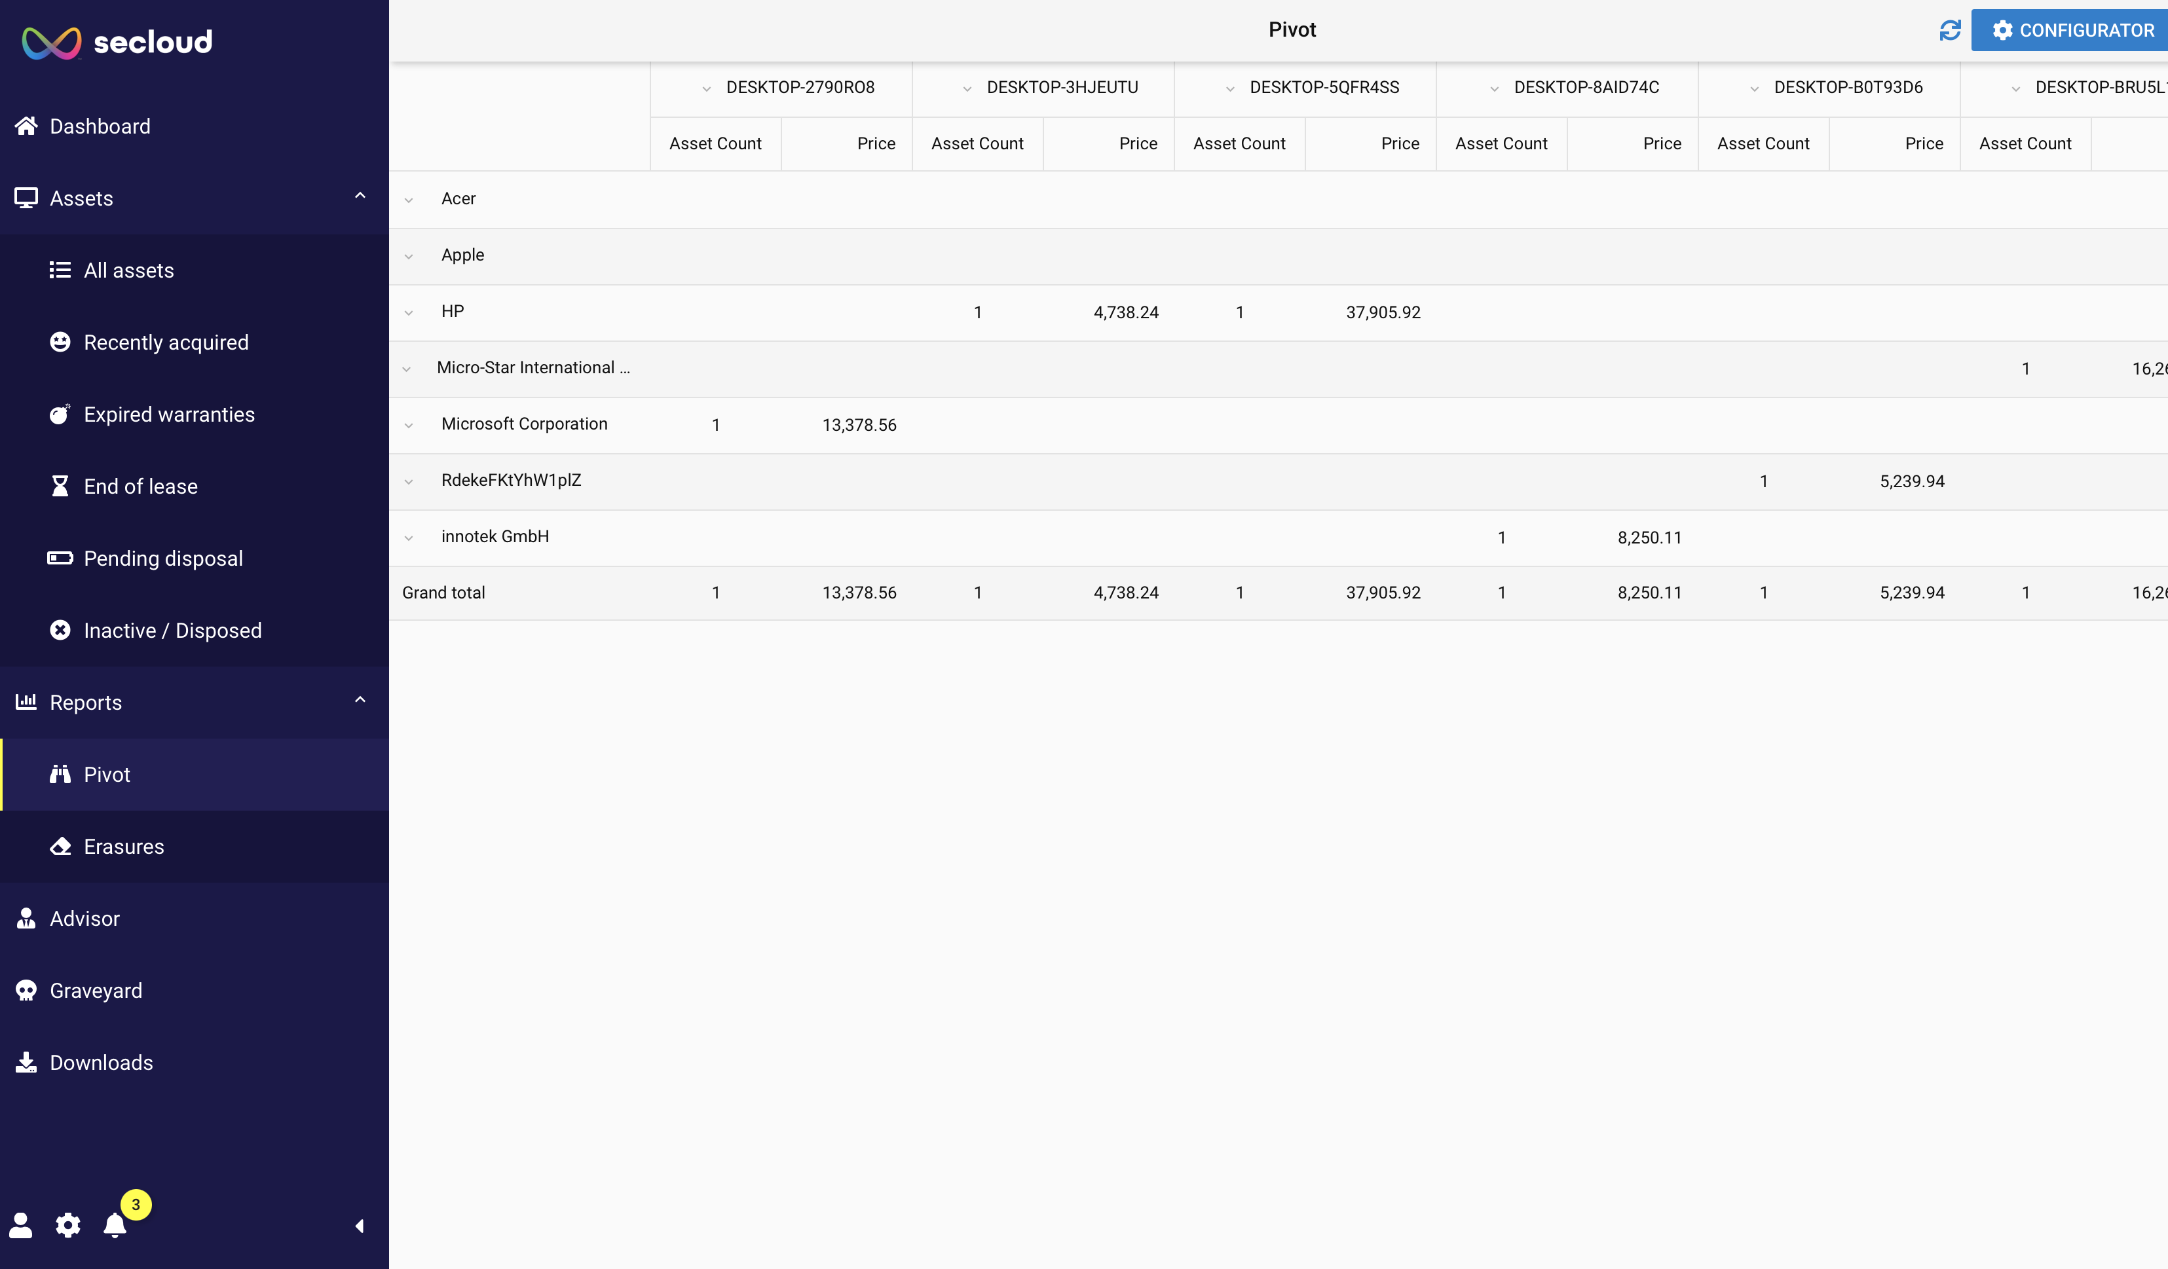

Device valuation
secloud automatically set a value on your devices based on extensive input from various databases and AI valuation. It gives you full control of when to dispose, re-use or sell your devices from a financial point of view as well as the technical.

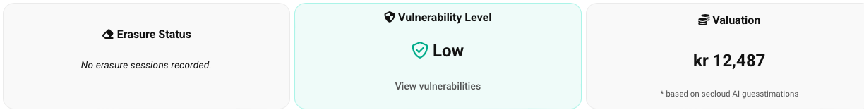

Azetwyze cyber security features

Purpose & functionality
Azetwyze includes risk management and threat intelligence features.
It continuously scans for vulnerabilities, misconfigurations, and suspicious activity, providing security teams with actionable insights to prioritize and mitigate risks.

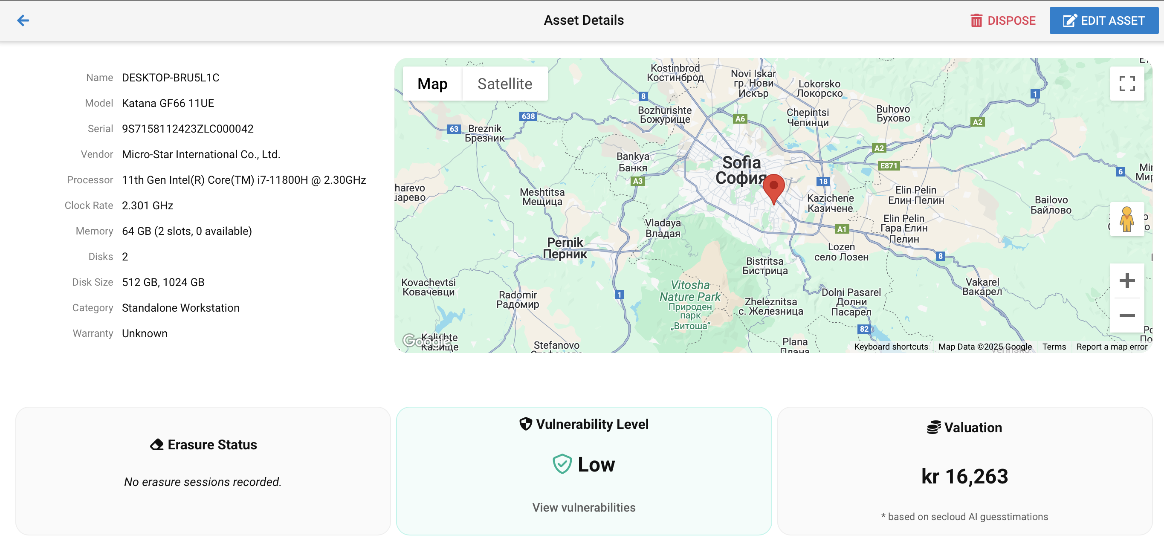

Key features

Real-time vulnerability assessment:
- Automated scans of OS and application layers, aligned with common vulnerability databases (e.g., CVE, NVD).
- Assigns criticality scores to help prioritize efforts.
- Alerts on insecure networks and includes geo-fencing and geo-location.

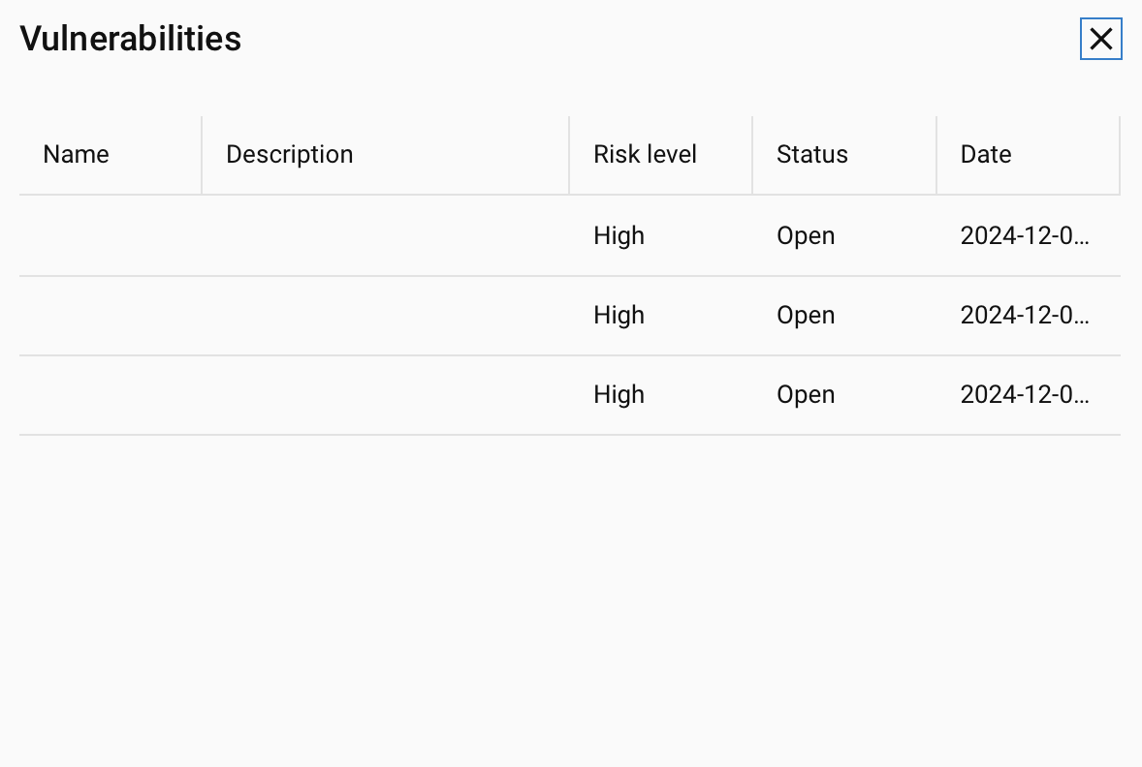

Threat intelligence integration:
- Aggregates threat data from external sources, flagging IPs, domains, insecure networks, behavior or files known to be malicious.
- Correlates local events with global threat feeds to detect emerging attacks.

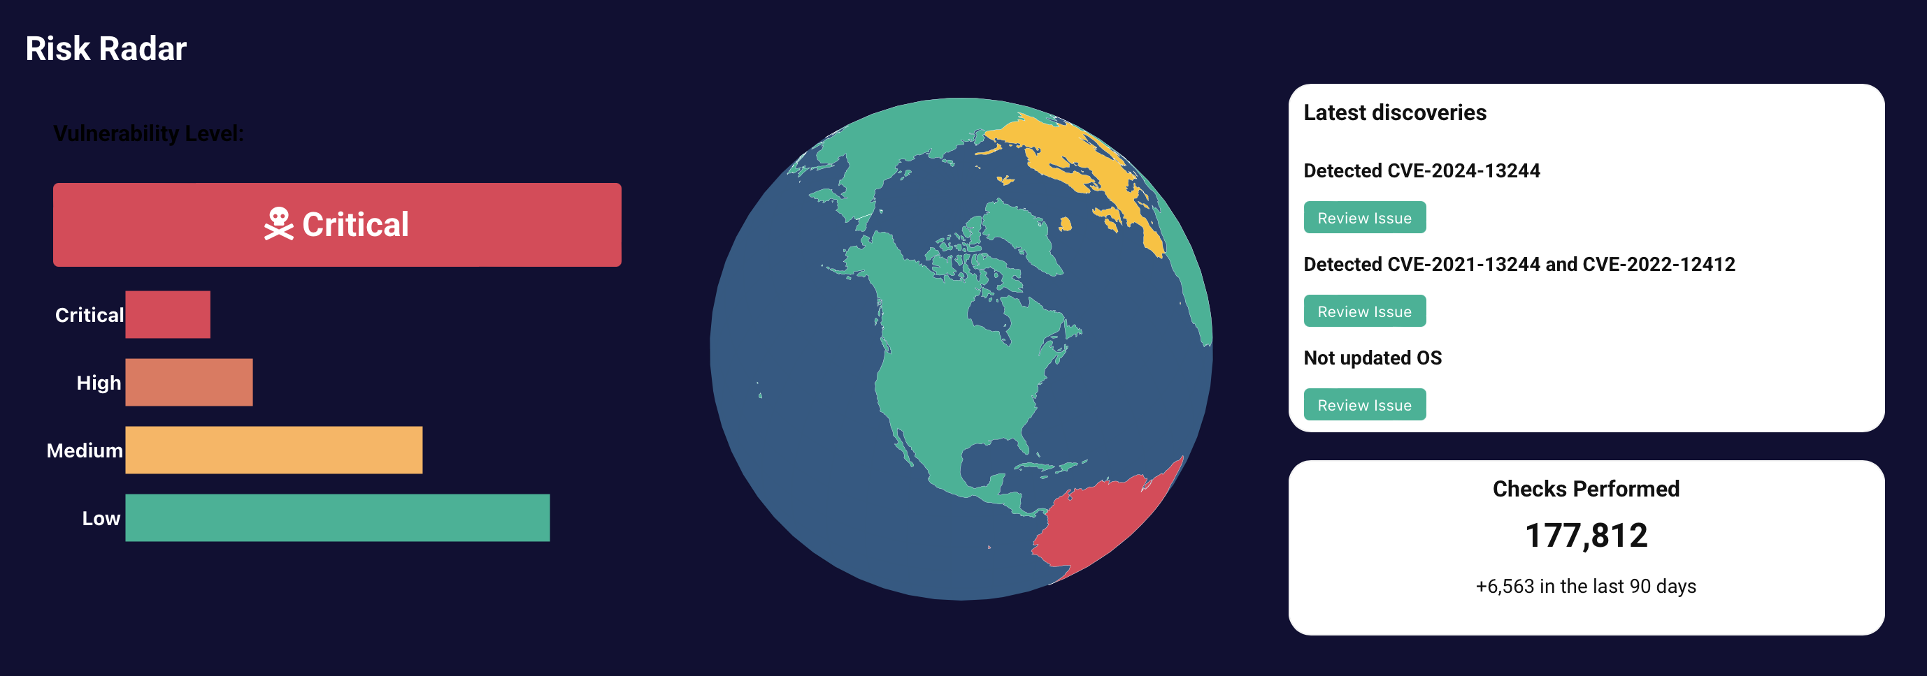

Config & Policy Compliance:
- Validates device configurations against best-practice benchmarks (e.g., CIS Benchmarks).
- Alerts on deviations.

Risk Prioritization & Workflow:
- Generates a dynamic Risk Heatmap, highlighting highest-impact vulnerabilities.
- Enables incident assignment, escalation, and resolution tracking within the platform.

azetwyze helps you regain control through:
- Early threat detection: Spot vulnerabilities before they become breaches.
- Efficient triage: Focus resources on the most impactful risks first.
- Integrated view: Combine threat intelligence with compliance checks for a complete security posture overview.

secloud azetwyze summarized:
- Complete visibility: eliminates blind spots with continuous asset discovery.
- Improved efficiency: Reduces manual asset tracking with real-time updates and automated workflows.
- Enhanced security: Identifies vulnerabilities or unauthorized use and behaviour that could pose security threats (with Risk Radar).

Elimino and Eliminato

Elimino and Eliminato are secloud’s secure data erasure solution, designed to irreversibly sanitize sensitive information from storage devices—whether on-premises or remote. This module ensures data is fully destroyed in line with legal and industry requirements, leaving no recoverable traces behind.

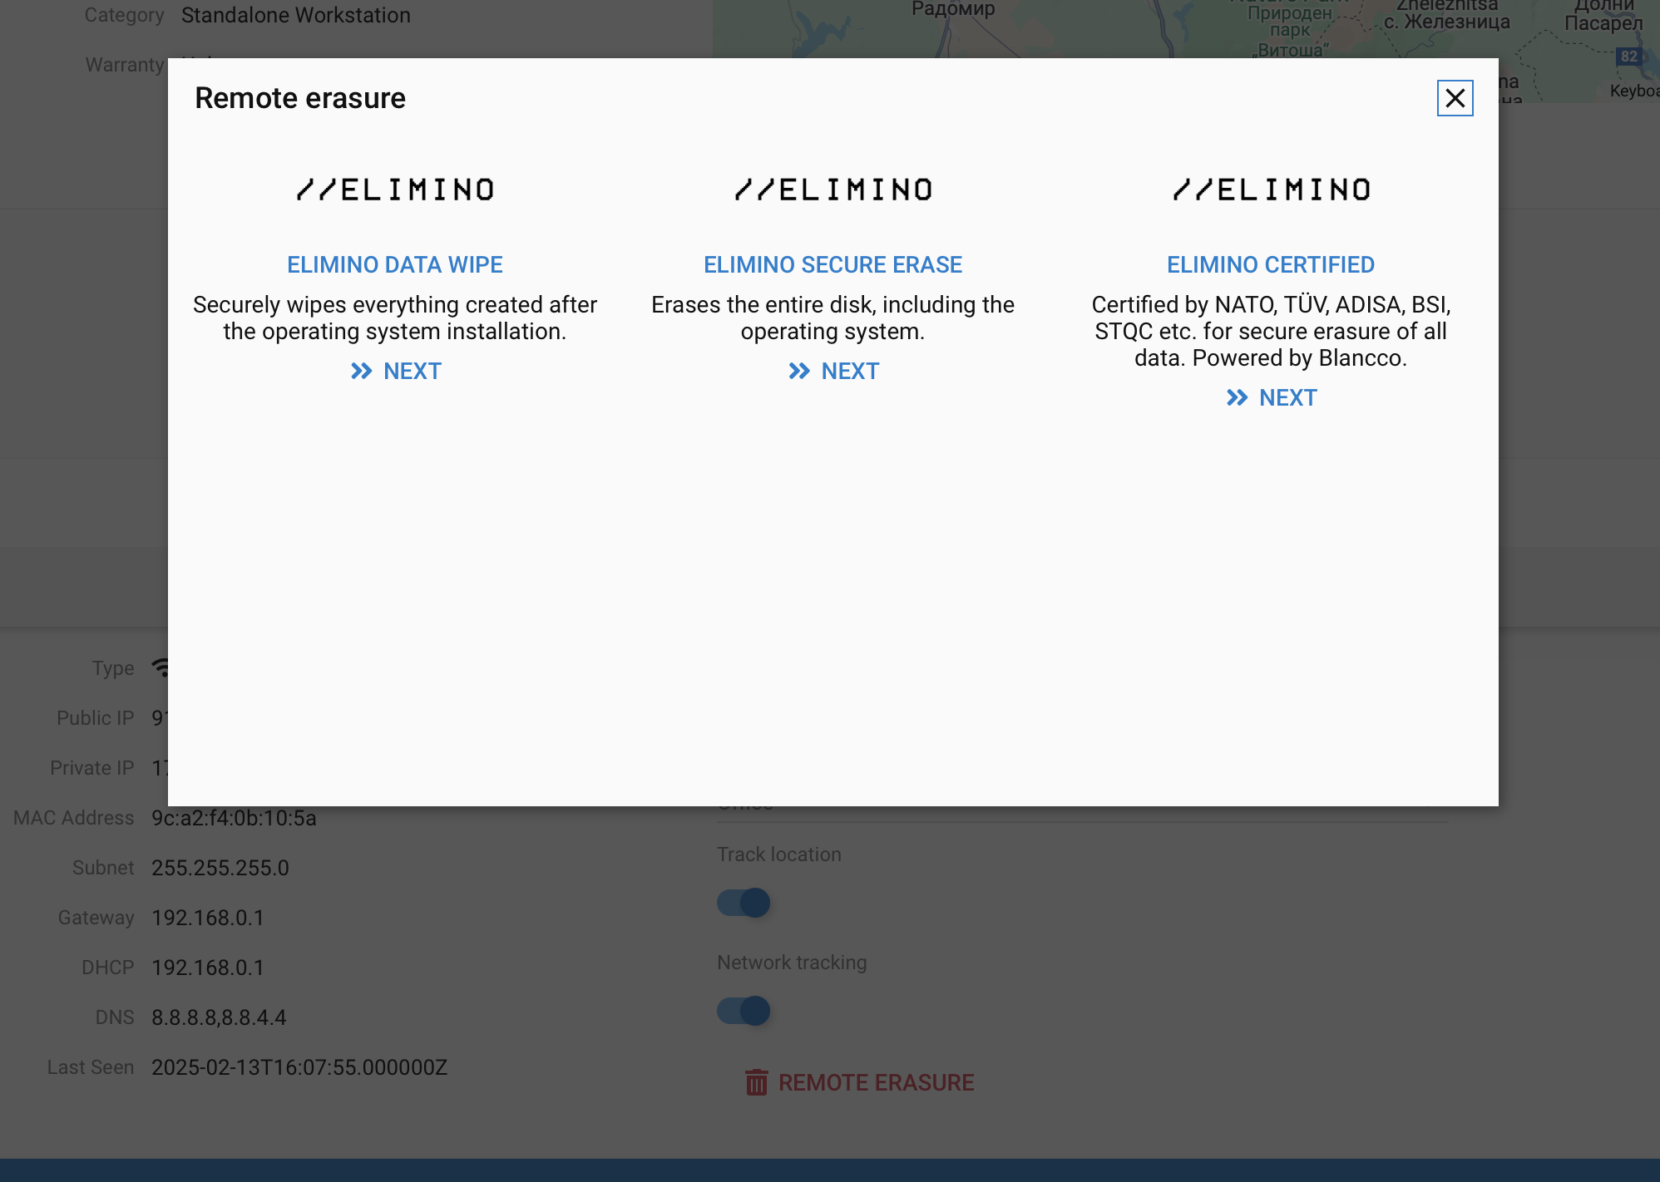

Key features

Certified data erasure solutions:
- Supports standards like NIST 800-88, DoD 5220.22-M, and ISO/IEC 27040.
- Multiple overwrite passes and cryptographic erasure methods to meet different security needs.

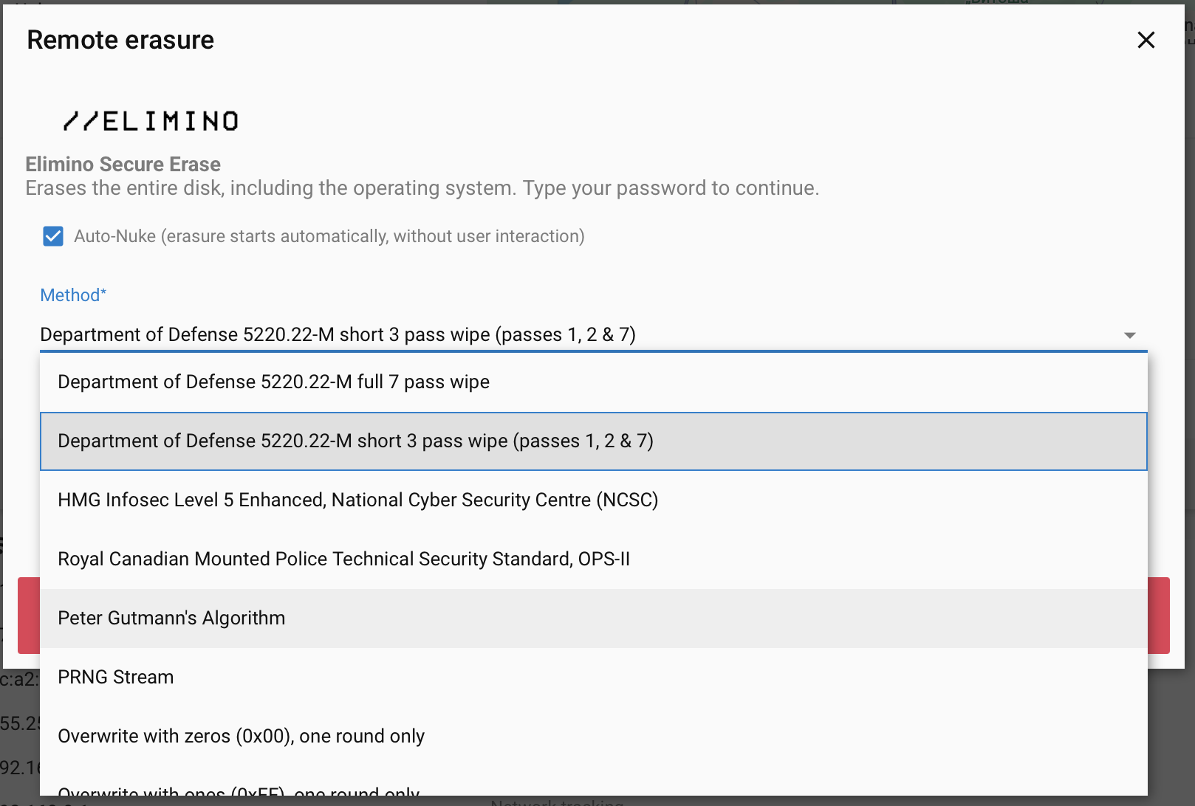

Remote erasures, encryption and wipes:
- Trigger erasure tasks for devices located in remote offices or employees’ homes.
- Integrates with device management platforms (e.g., MDM, EMM solutions) for remote triggers.

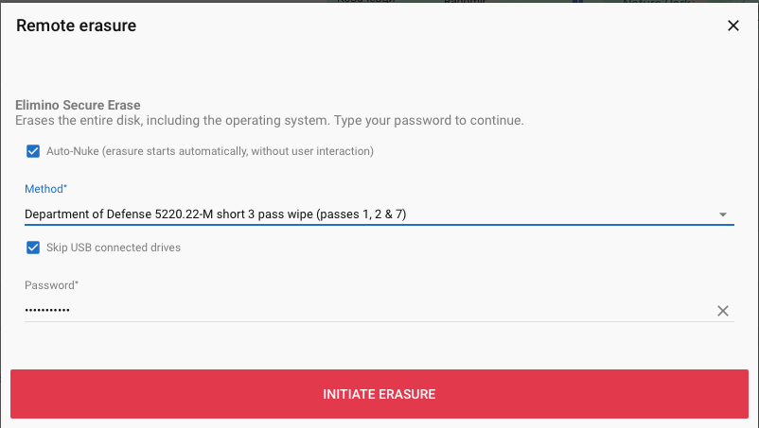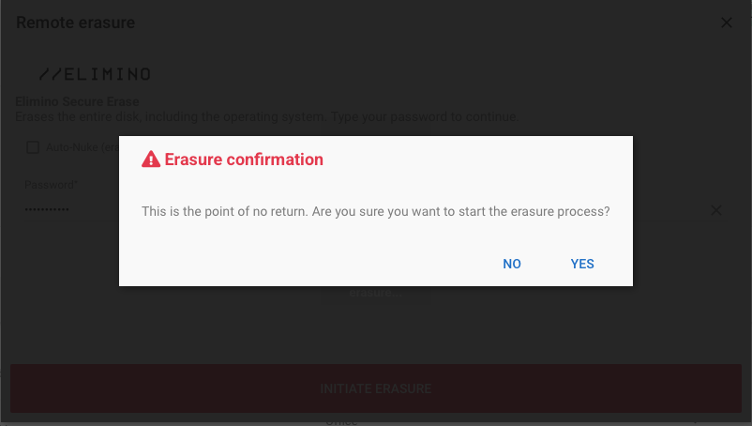

Granular scheduling & reporting:
- Scheduled or on-demand erasure jobs, with real-time progress tracking.
- Automatic generation of Erasure Certificates to prove compliance.

Tamper-proof audit trails:
- Maintains cryptographically signed logs of every erasure event.
- Helps fulfill compliance obligations for data privacy, disposal, and chain-of-custody.

Secure your data with Elimino:
- Secure decommissioning: Safely retire devices or reallocate assets without risk of data leakage.
- Regulatory compliance: Meets strict disposal requirements of GDPR, HIPAA, and other frameworks.
- Easy, centralized control: Efficiently manage data destruction from a unified console.

ElimiNATO

Purpose & functionality
Eliminato extends the secure erasure capabilities of Elimino with additional NATO and other certifications.ElimiNATO is powered by Blancco with secloud´s special touch on top of it.
As Elimino, it includes advanced workflows, offline erasure options, and deeper integrations to cater to enterprise demands for mass data sanitization and specialized hardware.

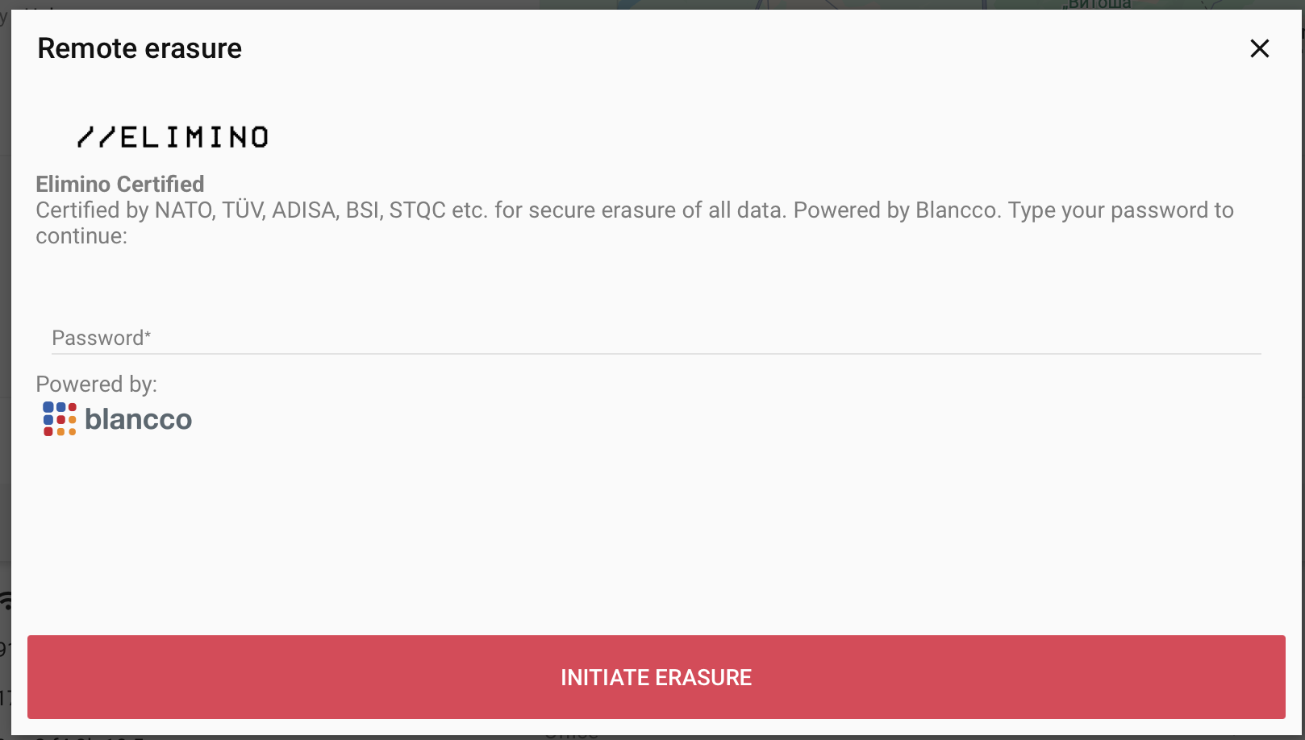

Key features
High-Volume erasure workflows:
- Batch management for dozens or hundreds of drives simultaneously.
- Load balancing to ensure parallel erasures without performance bottlenecks.

Specialized hardware integration:
- Supports dedicated erasure appliances for on-premises data centers.
- Offers hardware-based encryption key management to accelerate cryptographic erasure.

Remote & offline erasure capabilities:
- Securely erases devices with limited connectivity or offline endpoints (e.g., warehouse, end-of-life laptops).
- Custom scripts or USB boot options to handle one-off, offline erasures.

Regulatory & forensics assurance:
- Incorporates advanced forensic-grade wiping methods recognized by law enforcement and defense sectors.
- Detailed chain-of-custody logs for each device, ensuring compliance with strict record-keeping rules.

With Eliminato you get
- Enterprise-grade scale: Ideal for data centers, large corporate infrastructure, and service providers.
- Future-proof architecture: Continually updated algorithms and hardware support.
- Robust compliance coverage: Additional specialized certifications and documentation for heavily regulated industries.

Integrations & ecosystem

secloud’s modular design ensures streamlined integrations into existing workflows. Each module can operate independently or as part of a larger security architecture. Common integration points include:

- SIEM & SOAR Tools (e.g., Splunk, IBM QRadar) for alert correlation and automated incident response.
- IT Service Management (ITSM) platforms (e.g., ServiceNow, Jira) for ticketing and asset-tracking sync.
- Endpoint management (e.g., Microsoft Intune, VMware Workspace ONE) for remote configuration and wipe commands.
- Cloud platforms (AWS, Azure, GCP) to extend discovery, compliance checks, and erasure to cloud environments.

Features overview

Webapp user dashboard  Fílterable asset overview  Automatic enrolment  Company, office and group hierarchy  User allocation  Hardware component overview  Service and maintenance overview  Warranty end report  Browse installed software  Custom charts and reporting  Custom asset tags  Role based access control | Geolocation  Geofencing  Insecure network alterts  CISA known exploited vulnerabilities  Vulnerability score  Remote encryption  Remote kill-pill  OS User logging  Audit queries and user activities  Security and device advisory  Graveyard overview  Asset valuation | Access to remote certified data erasure (pay per erasure) including:  Secure remote erasure  Secure on-site erasure  Tamper proof erasure certificates  Secure remote erasure – keeping OS intact  NATO Certified data erasure  Extensive support of different OS and disks

Deployment options

Cloud SaaS:
secloud elimino and azetwyze are a cloud native platform delivered from our secure Norwegian and European datacenters.
- Fully managed in secloud’s secure cloud environment.
- Automatic updates and minimal infrastructure overhead.

On-premises erasures
secloud elimino and eliminato can be delivered as on-premises solution to meet specific regulatory or business requirements. Meaning that secloud can be used for highest possible security compliance.
This is ideal for highly regulated industries with strict data residency requirements.
- Deployed behind the corporate firewall with complete data control.

Hybrid approach:
Splits modules between on-prem and SaaS, e.g., Elimino on-prem for secure wiping, while the rest of secloud portfolio runs in the cloud. You can also run remote erasures through the cloud and specific erasures on-prem. Azetwyze always runs in the cloud.
With this option you can balance performance, compliance, and resource constraints.

Security & compliance framework

secloud places cybersecurity and privacy at the forefront:

- Encryption in transit and at rest: Ensures data is protected during scanning, storage, or wiping events.
- Role-based access control (RBAC): Granular user permissions within each module.
- Audits & certifications: Aligns with ISO 27001 for Information Security Management; can assist with HIPAA and PCI DSS compliance (depending on local regulations and architecture).
- Incident Management: Built-in alerts and logs for quick triage of anomalies or system misuse.

Maintenance & support

- 24/7 Technical Support: Through email, ticketing systems, or phone (depending on Service Level Agreements).
- Continuous Updates: Automated or manual updates for vulnerability databases, compliance rule sets, and erasure algorithms.
- Professional Services: Implementation guidance, custom integrations, and advanced policy configuration available for organizations needing additional expertise.

Pricing & licensing overview

secloud typically offers subscription-based licenses tailored to the modules an organisational needs you might have. Subscription is equal to the number of devices registered in the dashboard.

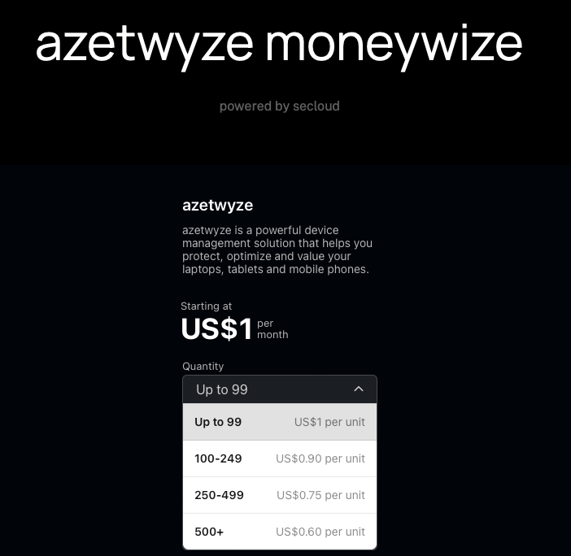

secloud Elimino and ElimiNATO pricing

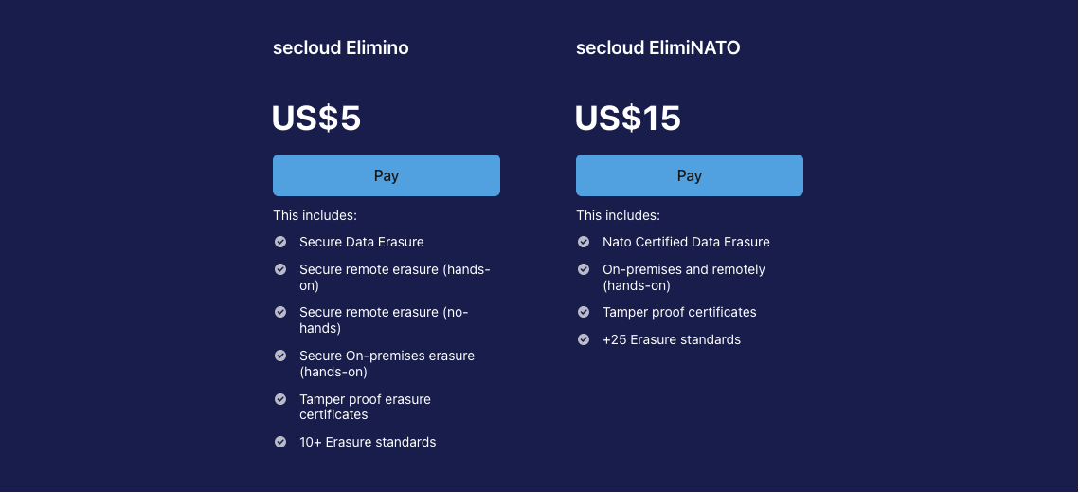

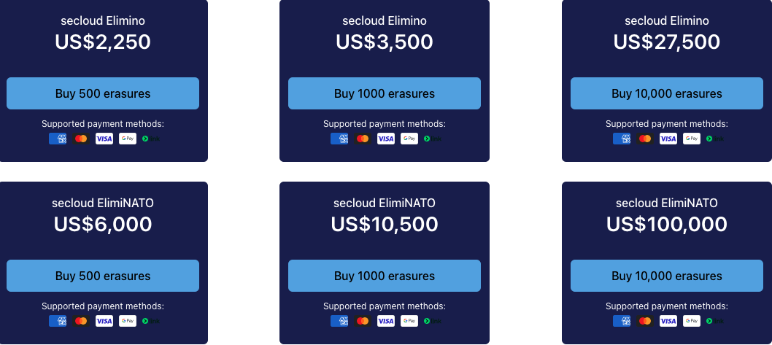

Contact secloud’s sales team for a detailed quote based on your specific environment and security needs.

Getting started with secloud

Step 1: Book a demo or skip right to step 2
Experience a live walkthrough of each module’s capabilities and use cases.

Step 2: Order secloud online or through your sales rep
Our online ordering possibilities are just as great as our sales reps.

Step 3: Scope & integration planning
Work with secloud’s consultants to define your organization’s objectives and integration points.

Step 4: Deployment & configuration
Set up secloud in the cloud or start your on-premises erasures and integrate with existing systems if required.

Step 5: Training & enablement
Work with secloud to train internal teams on daily operations, best practices, and compliance controls.

Step 6: Ongoing monitoring & support
Regularly review risk dashboards, asset environment and data erasure logs to maintain a secure environment.

secloud offers a comprehensive security and data management suite that addresses the full lifecycle of digital assets—from discovery and risk assessment to compliance management and secure data destruction. By leveraging the power of Azetwyze, Risk Radar, Compliance Pulse, Elimino, and Eliminato, organizations can maintain a proactive security posture while ensuring compliance with stringent data protection regulations.

With secloud, you not only see and secure your environment—you also gain confidence in your ability to meet evolving regulatory and threat landscapes. Through modular architecture, deep integrations, and expert support, secloud stands as a trusted partner in safeguarding your most valuable resource: your data.

References & Additional Resources

- NIST Special Publication 800-88 (Guidelines for Media Sanitization)
- GDPR Articles on Data Minimization & Erasure (Regulation (EU) 2016/679)
- ISO 27001 (Information Security Management System Standard)
- CIS Benchmarks (Industry-accepted system hardening guidelines)

(All references provided for informational purposes—please verify exact compliance requirements in your jurisdiction.)

